Advanced : Creating Earthquakes

Reload this article and prepare it for printing.
(removes banner ad and menubar and sets new width for page)
This article was last updated on Wednesday, January 30, 2002
Written by:
Cralex NS
cns@planetunreal.com
How to make a small EarthQuake in your map?
(Note: My first tutorial, weeh. I hope you can understand if not ICQ#91846003 me. This tutorial is for experienced mappers.)

Go launch the UED and open up your map.
Open up the Actor Browser, expand Keypoint and select Earthquake.
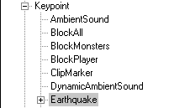
Now place your Earthquake where you want it to shake players :)
Open up the properties of the Earthquake actor
expand Events and write the tag `quake`
expand Earthquake
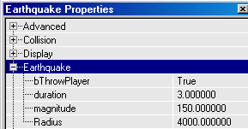
ThrowPlayer = True, if you want the player to be `thrown around`
duration = How long you want the quake to be?
magnnitude = How much you want to throw the player?
radius = Radius of your shakings (If you want the EarthQuake to be everywhere on your map,
set the amount very high)
We need some sound on this Quake to make it real, so open up the Class Browser once more and
expand Triggers and then select SpecialEvent
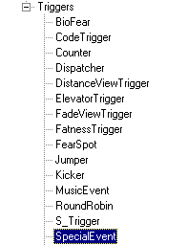
Place the SpecialEvent somewhere around your Earthquake Actor.
Open the properties for the SpecialEvent now
expand Events and write the tag `quake`
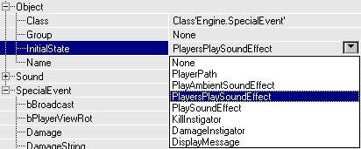
Expand Object and select InitialState>PlaySoundEffect
(if you wanted the Quake everywhere select: PlayersPlaySoundEffect)
Now Expand SpecialEvent>Sound and select the sound you wanna use. (Ambiant Outside is a nice pack :))
Now we have an EarthQuake but no we are not finished yet, we want the EarthQuake to be
started somehow, this can be done one several ways, timedtrigger, trigger, TeamTrigger etc.
Just make the Event>Event of the trigger "quake" :)
tutorial by Cralex NS - cralle@wanadoo.dk

